Documentation of Code

The program is written and executed under MATLAB 2016 b

一、Main Instructions for Use：

|  |  |  |
| --- | --- | --- |
| **main program** | **introduce** | **Output** |
| main9__ALL.m | 500 groups of simulations for n = 100，see Figure 4 | Referral network results in IK, IU, NK and NU |
| main9__ALL_rand2.m | 500 groups of simulations for n = 100，see Figure 2 | The result of random Referral network |
| main9__ALL_netlen.m | 500 groups of simulations for n = 50，see Table 6 | Diameter of Referral network in IK, IU, NK and NU |
| monopolist_profit__ALL2.m | Calculating the monopoly profit of Referral network | the monopoly profit in IK, IU, NK and NU |

**main9__ALL.m** is the main program of simulation, which can be started by running directly. But **main9__ALL.m** must be executed first, before executing **main9__ALL_rand2.m** or **monopolist_profit__ALL2.m**,

**1.1** **Parameter definition**

In the **main9__ALL.m**, you can set initial values for the **times of simulations**, and **market size**.

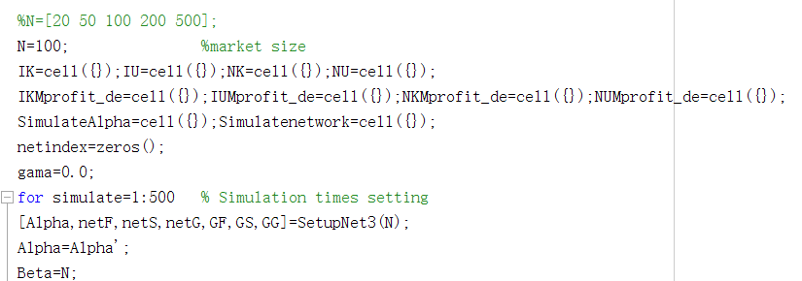

**1.2** **Result review：**

Note that all results are stored in **cell** form for easy reading.

**SimulateAlpha** stores parameter settings(Alpha) for each simulation

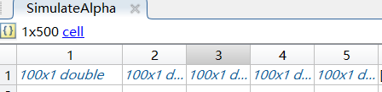

**SimulateAlpha {1,** simulation times**}.** SimulateAlpha stores the preferences randomly assigned to each user in each simulation.

In main9__ALL.m or main9__ALL_rand2.m, the results of referral network are stored in **IK, IU, NK and NU.** Each variable is in the format of 500*2*3, respectively represent 500 sets of simulations, 2 ways to start, 3 kinds of network structure results.

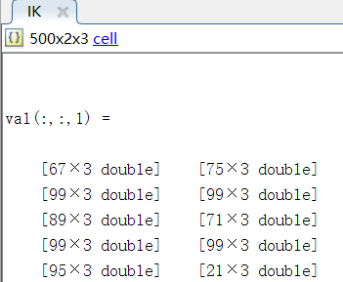 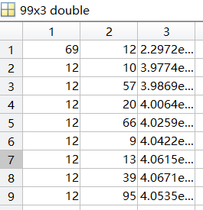

The results of each referral network are shown on the right. Each link of the referral network is stored, and each row represents a link. From left to right are the recommender, receiver, and profit of the link.

In monopolist_profit__ALL2.m, the total profits of monopolists in IK, IU, NK and NU are stored in **monopolistIK**, **monopolistIU**, **monopolistNK** and **monopolistNU** respectively

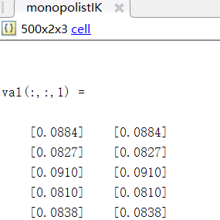

In main9__ALL_netlen.m, the diameter of referral network in IK, IU, NK and NU are stored in **IKnetlen, IUnetlen, NKnetlen** and **NUnetlen** respectively

二、Procedure contents：

|  |  |  |
| --- | --- | --- |
| **Main script** | | |
| **main9__ALL.m** | | **500 groups of simulations for n = 100** |
| **main9__ALL_rand2.m** | | **500 groups of simulations for n = 100** |
| **main9__ALL_netlen.m** | | **500 groups of simulations for n = 50** |
| **monopolist_profit__ALL2.m** | | **Calculating the monopoly profit of Referral network** |
| **Function** | | |
| **Basic function** | **Sub function** | **Main contents** |
| **SetupNet3.m** |  | Generate Initial Networks |
|  | **FreeScaleBA.m** | Generate scale-free networks |
|  | **randnet.m** | Generate stochastic networks |
| **getlinkIK.m** |  | Calculate the profit of each possible link in IK |
|  | **linkIK2.m** | Calculate the profit of a link in IK |
| **getlinkIU.m** |  | Calculate the profit of each possible link in IU |
|  | **linkIU2.m** | Calculate the profit of a link in IU |
| **getlinkNK.m** |  | Calculate the profit of each possible link in NK |
|  | **linkNK2.m** | Calculate the profit of a link in NK |
| **getlinkNU.m** |  | Calculate the profit of each possible link in NU |
|  | **linkNU2.m** | Calculate the profit of a link in NU |
| **GlinkIK3.m** |  | Calculate the total profit of monopoly in IK |
| **GlinkIU3.m** |  | Calculate the total profit of monopoly in IU |
| **GlinkNK3.m** |  | Calculate the total profit of monopoly in NK |
| **GlinkNU3.m** |  | Calculate the total profit of monopoly in NU |

Note: The basic function is called directly by the main script, and the sub function is called in the basic function or by itself.